Mission Statement: The CALIFORNIA ASSOCIATION OF REALTORS® Housing Affordability Fund plays an active role in addressing the ongoing housing affordability crisis facing our state. H.A.F. will raise and distribute funds in partnership with local associations and other groups to promote housing and homeownership.
Presiding:
Chair: James Garcia, Imperial County Association of REALTORS®
Vice Chair: Rolanda Wilson, Contra Costa Association of REALTORS®
Vice Chair: Arlene Byerly, California Desert Inland Gateway Association of REALTORS®
Committee Liaison: Eugene Pak, San Francisco Association of REALTORS®
Staff: Sara Sutachan and Marc Farfel
I. Welcome, Key Dates & Introductions 2:00 PM James / Marc
• Rosters / check-in
• Antitrust and Inclusivity reminders
II. HAF Mission Statement (Possible Revision) & Opening Remarks James
III. Potential New Statewide Homeownership & or Continuing Existing Grant Program
• Following the Nevada County Association of REALTORS® presentation in Sacramento, discuss development of a statewide grant program modeled on the Strengthening Community First-Time Home Buyer Grant Program.
IV. C.A.R. CARES Update James / Lindsey / Sabrina Brown
V. 2026 Working Group Recommendations & 2027 Priorities James Rolanda Arlene
• Sustainability Team - sustainable funding and partnership recommendations
• AOR Grant Outreach / Education Team - grant education and outreach recommendations
• Video Team - homeowner and member testimonial recommendations
• What should HAF carry forward into 2027?
VI. Open Questions / New Business - James
VII. Chair's Closing Remarks & Recognition of 2027 Chairs Eugene / Marc / Sara
VIII. Adjournment

Housing Affordability Fund Winter 2027
Explore
Learn & Thrive
Education
Meetings & Events
Marketing Tools
Knowledge Center
Home
Meetings & Events
C.A.R. Board of Directors and Committees
Current Meeting Materials
Housing Affordability Fund Fall 2026
Print Email Save
Share
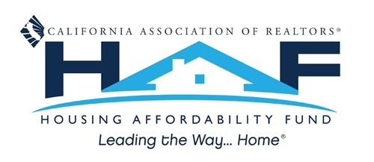
Welcome to the 2026 Housing Affordability Fund (HAF) Committee
We are pleased to announce that the Housing Affordability Fund Committee will convene in Long Beach, CA, on Tuesday, October 6, 2026, from 8:00 AM to 10:30 AM. The meeting will be held at the Hyatt Regency Hotel in Beacon Room A.
To ensure a productive discussion, we kindly request that you review the materials below:
- Agenda
- Spring 2026 Committee Meeting Minutes
- HAF Make a Difference Newsletter
- HAF Key Dates Calendar
- C.A.R. Member Benefits Guide
- Local Association Grant Application Process
We look forward to your participation and valuable contributions.
If you have any questions or require assistance before the meeting, please do not hesitate to reach out to Marc Farfel at 213-739-8264 or via email at haf@car.org.

