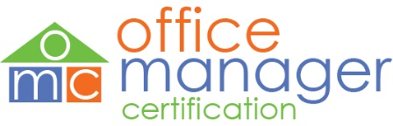

TO APPLY:
Submit this completed application along with copies of your exam transcripts and/or exam completion certificates to: education@car.org. Applications sent via email are strongly preferred. To apply by mail: C.A.R. Education, OMC Program, 525 S. Virgil Avenue,
Los Angeles, CA 90020. Please allow up to three (3) weeks upon receipt to process your application. Incomplete applications will take longer to process.
Please fill out this form in its entirety.
Name as you would like it to
appear on your certificate
Street Address | City |  | State | Zip code
Email address |  | Phone number
DRE or NRDS#

- You must take and successfully complete all FOUR (4) of the OMC Required Courses.
- You must also take and successfully complete ONE (1) of the OMC Course Electives.
- You may take as many as you want and take them in any order.
- Please indicate which courses you have taken and when you passed the course exam.
- Only courses taken within the last year (12 months) apply.

REQUIRED COURSE | DATE EXAM PASSED
Nuts & Bolts: The Broker’s Day-to-Day
Team Management for Brokers
California Human Resource Law for Brokers
zipForm ® Broker Edition Training
COURSE ELECTIVES – (Choose One)
The New Broker’s Benchmark: Prepare and Perform!
Management and Supervision
Successful Seller Client Systems
Leadership - Crystalline VISION

