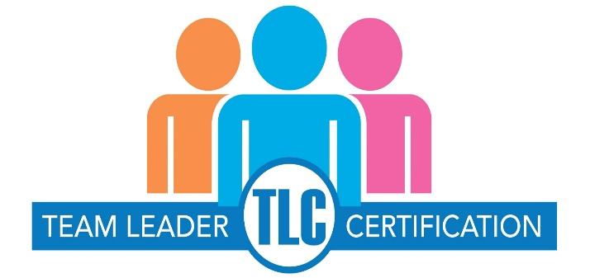

TO APPLY:
Submit this completed application along with copies of your exam transcripts and/or exam completion certificates to: education@car.org. Applications sent via email are strongly preferred. To apply by mail: C.A.R. Education, PMC Program, 525 S. Virgil Avenue,
Los Angeles, CA 90020. Please allow up to three (3) weeks upon receipt to process your application. Incomplete applications will take longer to process.
Please fill out this form in its entirety.
Name as you would like it to
appear on your certificate
Street Address | City |  | State | Zip code
Email address |  | Phone number
CalBRE #

- You must take and successfully complete all FOUR (4) of the TLC Required Courses.
- You must also take and successfully complete TWO (2) of the TLC Course Electives.
- You may take as many as you want and take them in any order.
- Please indicate which courses you have taken and when you passed the course exam.
- Only courses taken within the last year (12 months) apply.

REQUIRED COURSE | DATE EXAM PASSED
I to We: Building and Working as a Team
Team Leader 2.0: The Team Leader
California Human Resource Law for Brokers/Teams
Best Practices for zipForm Plus® Team Leader Edition
COURSE ELECTIVES
Social Media for Teams
Save Time and Make Money with CRM
Leadership Advantage
Be a Team Transaction Wizard

