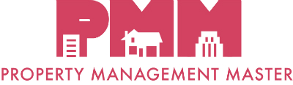

TO APPLY:
Submit this completed application along with copies of your exam transcripts and/or exam completion certificates to: education@car.org. Applications sent via email are strongly preferred. To apply by mail: C.A.R. Education, PMC Program, 525 S. Virgil Avenue,
Los Angeles, CA 90020. Please allow up to three (3) weeks upon receipt to process your application. Incomplete applications will take longer to process.
Please fill out this form in its entirety.
Name as you would like it to
appear on your certificate
Street Address | City |  | State | Zip code
Email address |  | Phone number
CalBRE #

- You must take and successfully complete all EIGHT (8) Property Management courses,
- You may take them in any order.
- If you have already taken any of the above courses in the last 2 years, you may apply the courses to your Property Management Master Certification. You DO NOT have to retake them.
- Below, please indicate when you passed each course’s exam.
COURSE | DATE EXAM PASSED
PMC 1: Residential Property Management
PMC 2: Professional Property Management
PMC 3: Larger Apartment Buildings and Commercial Properties
PMC 4: Trust Funds, Fair Housing, and Legal Aspects of Property Management
PMC 5: Working with Investors
PMC 6: Vacation Rental Management
PMC 7: Selling Apartment Buildings
PMC 8: All Creatures Great and Small: Rules About Assistance Animals
Real Estate Investing Made Clear
Beneath the Surface - Understanding the Anatomy of a Home
Spring Cleaning Your Rental Property

