TO APPLY:
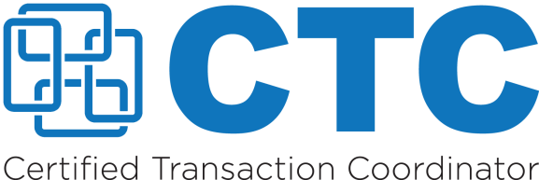
Submit this completed application along with copies of your exam transcripts and/or exam completion certificates to: education@car.org. Applications sent via email are strongly preferred. To apply by mail: C.A.R. Education, CTC Program, 525 S. Virgil Avenue,
Los Angeles, CA 90020. Please allow up to three (3) weeks upon receipt to process your application. Incomplete applications will take longer to process.
Please fill out this form in its entirety.
Name as you would like it to
to appear on your certificate
Street Address |  | City |  | State | Zip code
Email address |  |  | Phone number
- Non-licensed | - Licensed - Your BRE#

You must take and successfully complete the required transaction coordinator courses. Please indicate which courses you have taken and when you passed the course exam.

IF YOU ARE A NON-LICENSED APPLICANT
- Fundamentals of Transaction Coordination Date Exam Passed:
- Transaction Talk Workshop Date Exam Passed:
- Real Estate Do’s and Don’ts for Non-Licensees Date Exam Passed:
- Elective: Date Exam Passed:

IF YOU ARE A LICENSED APPLICANT
- Fundamentals of Transaction Coordination Date Exam Passed:
- Transaction Talk Workshop Date Exam Passed:
- Elective #1: Date Exam Passed:
- Elective #2: Date Exam Passed:

ELECTIVES (see above for requirements)
- All About Disclosures OR Disclosures 1 & 2: What You Need to Know
- California Residential Purchase Agreement (RPA)
- Risk Management
- Transaction Coordination 2: Beyond the Contract

